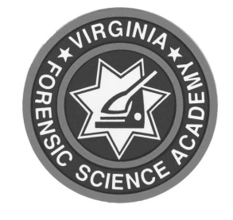
Virginia Department of Forensic Science
Laboratory Capabilities and Updates
Online Via Microsoft Teams
June 24, 2026

9:00 a.m. – 9:10 a.m. Roll Call

9:10 a.m. – 9:30 a.m. Welcome & Department Update Linda Jackson
Director

9:30 a.m. – 10:00 a.m. Forensic Biology Updates Brad Jenkins
Forensic Biology Program Manager

10:00 a.m. – 10:10 a.m. Toxicology Updates Jim Hutchings
Toxicology Program Manager

10:10 a.m. – 10:20 a.m. Chemistry Updates Robyn Weimer
- Trace Evidence Chemistry Program Manager
- Controlled Substances

10:20 a.m. – 10:30 a.m. Break

10:30 a.m. – 11:00 a.m. Physical Evidence Updates Sam Glass
-Latent Prints and Impressions Physical Evidence Program Manager
-Firearms -Digital Evidence

11:00 a.m. – 11:10 a.m. Evidence Receiving Updates Ellen Spain
Evidence Receiving
Program Manager

11:10 a.m. – 11:40 a.m. Training Updates Jeff Dwyer
Forensic Training Manager

